Identified Code Smells

* Tiago Coelho 54622:
  + Code Smell 1 – Speculative Generality:
    - Illustrating code snippet:

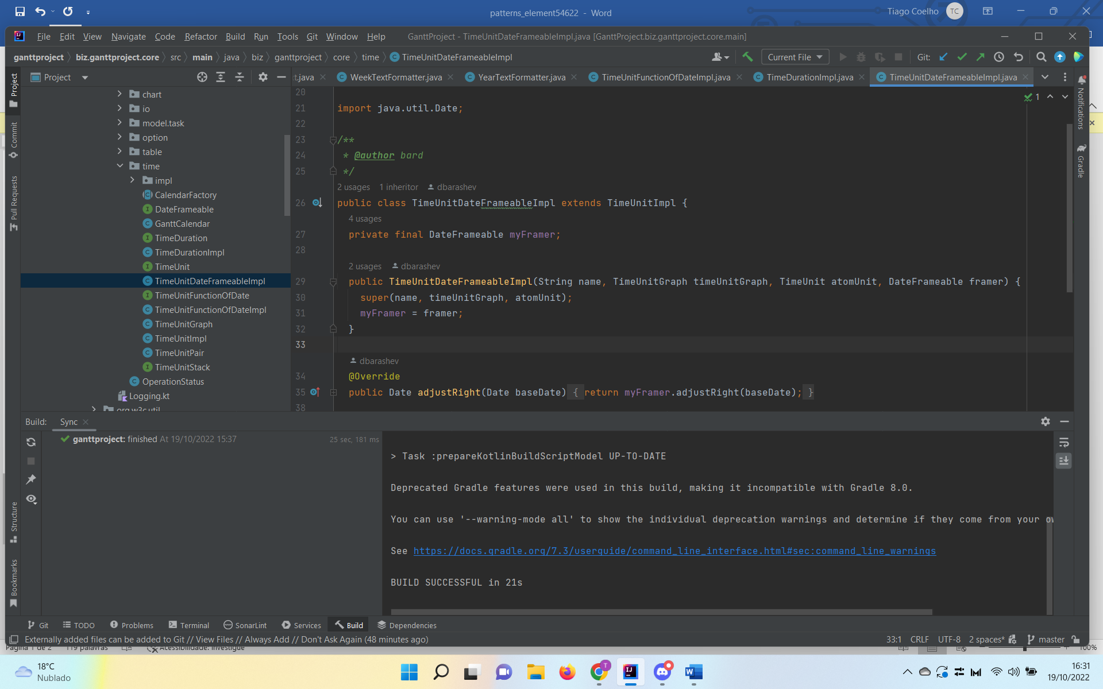

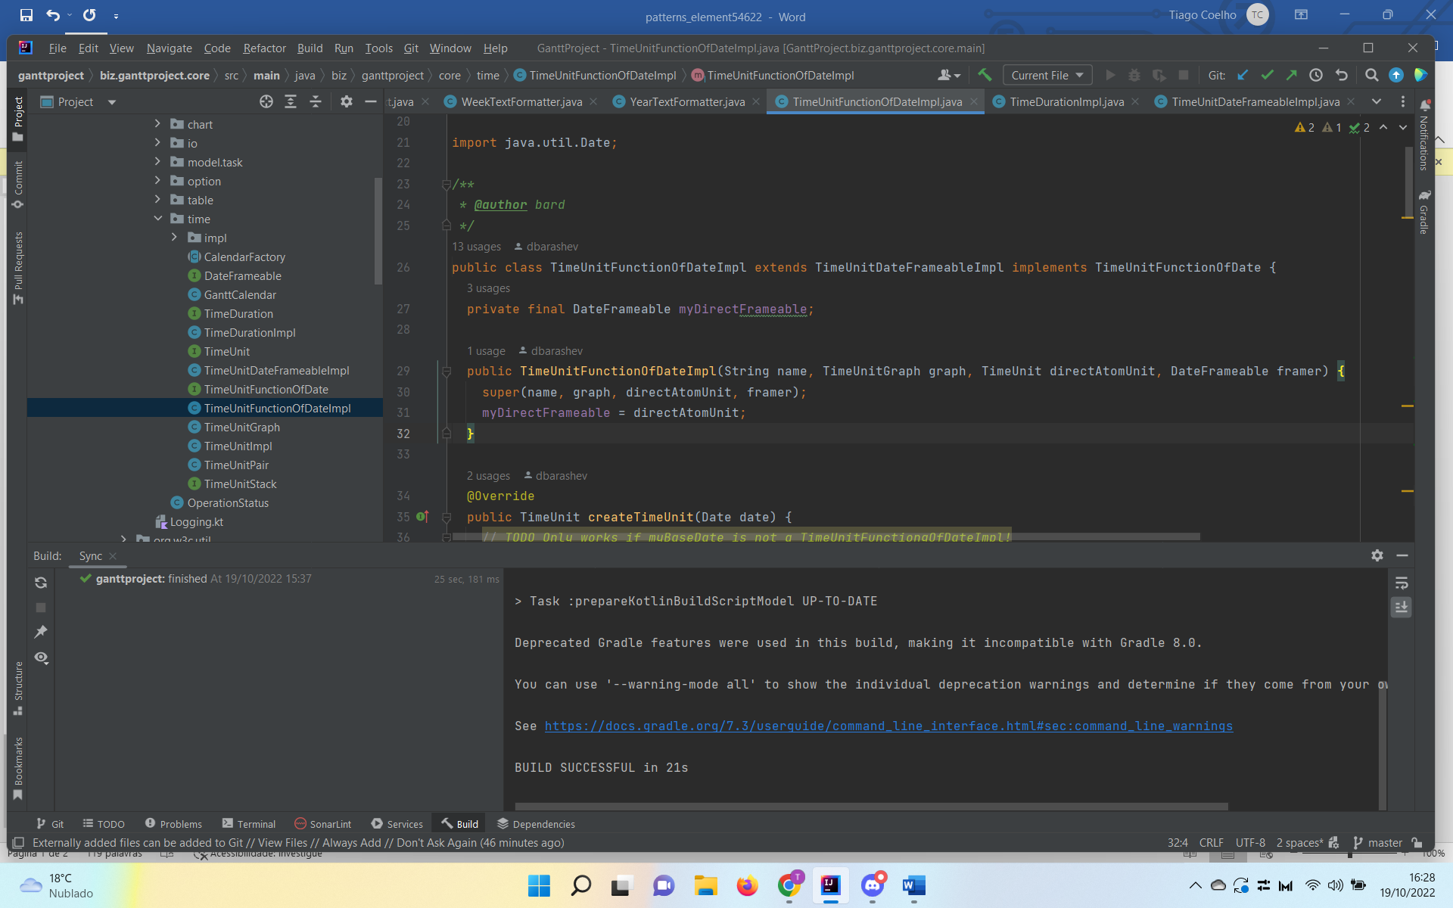

* + - The exact location on the codebase:

biz.ganttproject.core [core] -> src -> main -> java -> bizganttproject -> core -> time -> impl

* + - An explanation of the rationale for identifying this code smell:

The superclass “TimeUnitDateFrameableImpl” was created which, at the moment, is not necessary for the realization of this project, but it may be useful in the future.

* + - A refactoring proposal:

Implement the desired class without extending the superclass.

* + Code Smell 2 – Dead Code:
    - Illustrating code snippet:

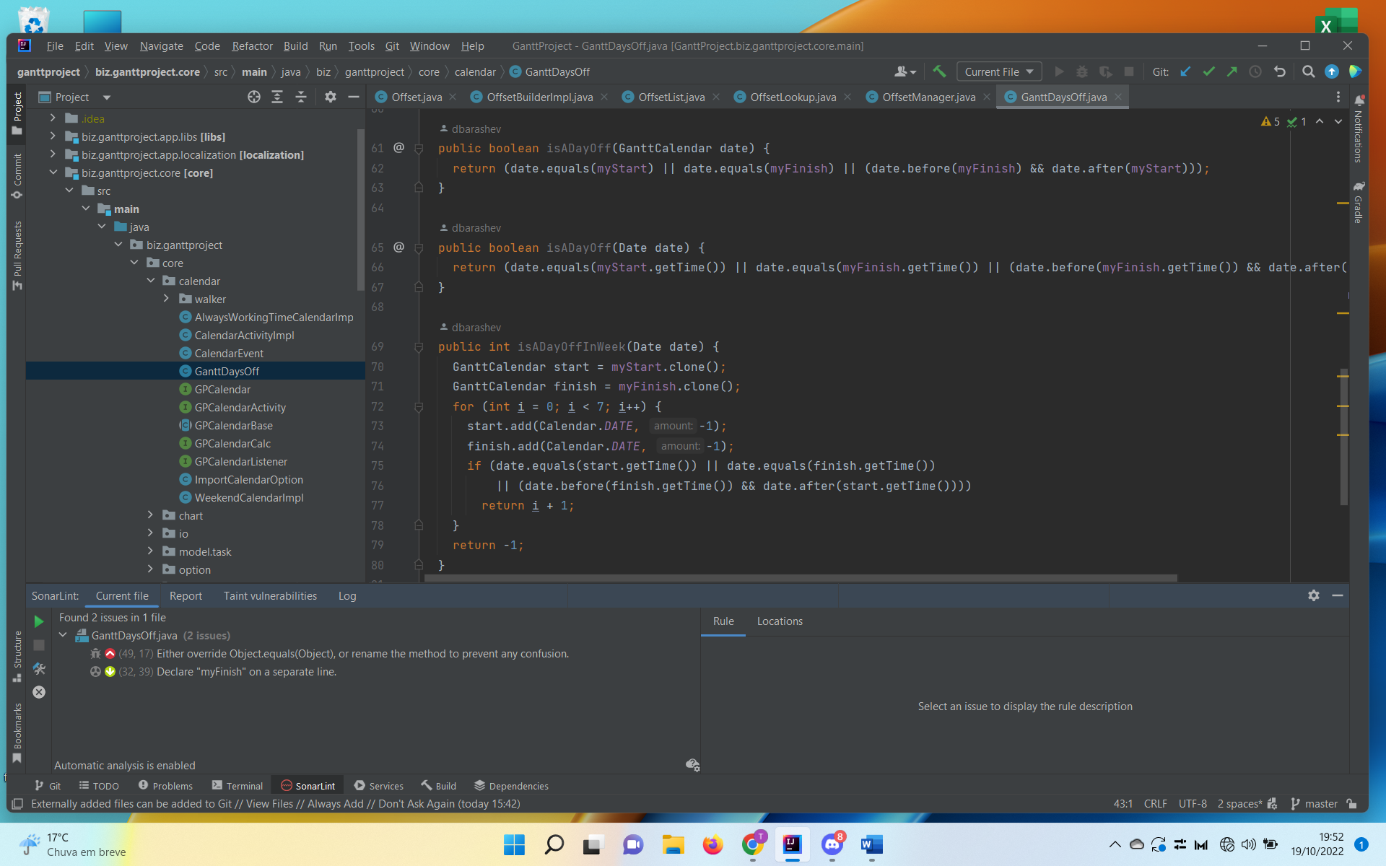

* + - The exact location on the codebase:

biz.ganttproject.core [core] -> src -> main -> java -> bizganttproject -> core -> calendar -> walker -> GanttDaysOff

* + - An explanation of the rationale for identifying this code smell:

Methods ´isDayOff (GanttCalendar date)´, ´isDayOff (Date date)´ and isDayOfffInWeek (Date date)´ are never used.

* + - A refactoring proposal:

Detele methods.

* + Code Smell 3 – Data Clump:
    - Illustrating code snippet:

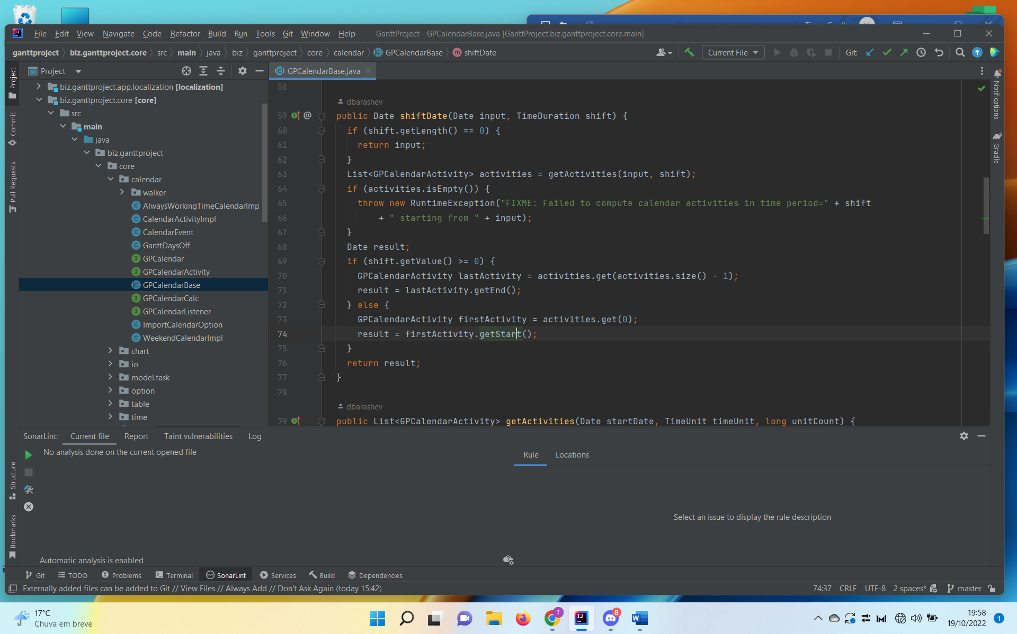

* + - The exact location on the codebase:

biz.ganttproject.core [core] -> src -> main -> java -> bizganttproject -> core -> calendar -> walker -> GPCalendarBase

* + - An explanation of the rationale for identifying this code smell:

The exception “RunTimeException” is handled in the middle of the method.

* + - A refactoring proposal:

This exception could be thrwon in this class, but could be handled in a diferente class with all other exceptions in the project.